Assessment Schedule – 2014

Music: Demonstrate aural understanding through written representation (91275)

Evidence Statement
Question | Achievement | Achievement with Merit | Achievement with Excellence
ONE | Chord Recognition
(a) | There are 12 chords and two cadences to be identified.  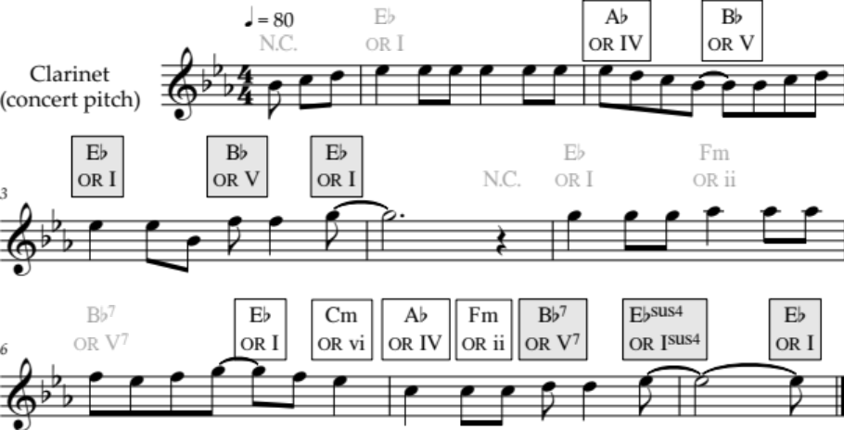  Cadence ①: Perfect  Cadence ②: Perfect
(b) | There are 12 chords and two cadences to be identified.  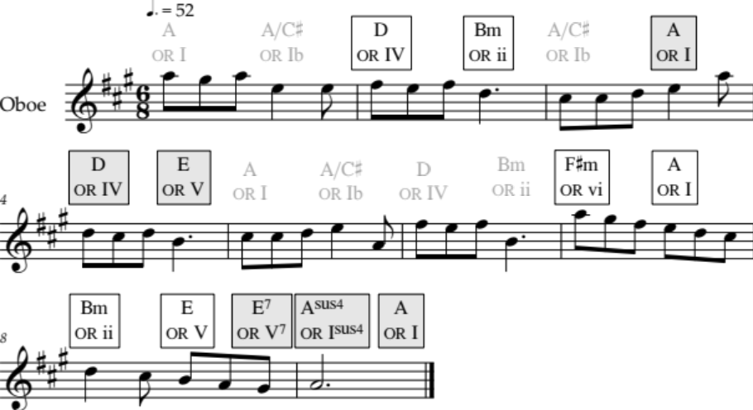  Cadence ①: Imperfect  Cadence ②: Perfect

N1 | N2 | A3 | A4 | M5 | M6 | E7 | E8
In BOTH parts of the question, identifies any ONE chord. | In BOTH parts of the question, identifies any TWO (of 12) chords in isolation. | In BOTH parts of the question, identifies any FOUR (of 12) chords in isolation. | In BOTH parts of the question, identifies any SIX (of 12) chords in isolation. | Identifies any FOUR progressions of TWO adjacent chords. | Identifies any SIX progressions of TWO adjacent chords. | Identifies TWO cadences | Identifies THREE cadences
 |  |  |  |  |  | AND  For any TWO cadences, identifies all three highlighted chords. | AND  For any THREE cadences, identifies all three highlighted chords.
N0= No response; no relevant evidence.

Question | Achievement | Achievement with Merit | Achievement with Excellence
TWO | Melodic and Rhythmic Dictation
(a) | There are two passages, and six melodic contours / melodic and rhythmic patterns to transcribe.  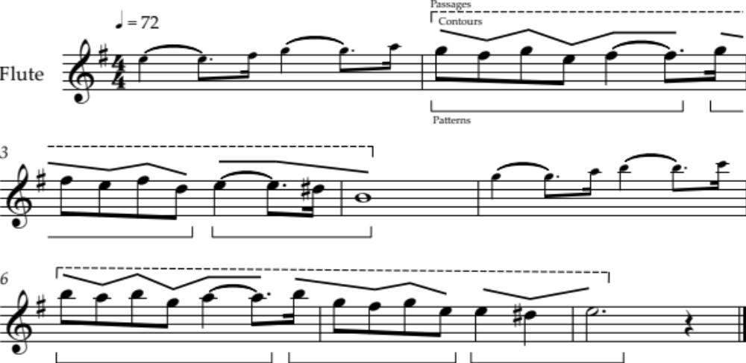
(b) | There are two passages, and six melodic contours / melodic and rhythmic patterns to transcribe.  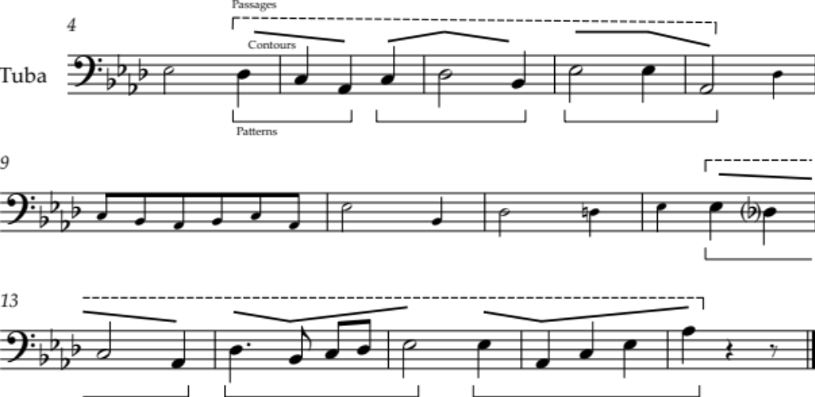
 | Note that accurate identification of a contour requires that its first and last pitches are appropriate in relation to the pitches that precede and follow it.

N1 | N2 | A3 | A4 | M5 | M6 | E7 | E8
Identifies any ONE contour. | Identifies any TWO (of 12) contours. | Identifies any THREE (of 12) contours. | Identifies any FOUR (of 12) contours. | Accurately transcribes THREE (of 12) patterns. | Accurately transcribes FOUR (of 12) patterns. | Transcribes TWO (of 4) passages accurately, with allowance for TWO inexact pitches or rhythms. | Transcribes THREE (of 4) passages accurately, with allowance for ONE inexact pitch or rhythm.
N0= No response; no relevant evidence.

Question | Achievement | Achievement with Merit | Achievement with Excellence
THREE | Elements and Expressive Features
(a) (i) | Identifies an instrument in the same immediate family as the instrument playing the melody:  - oboe. | Identifies the instrument playing the melody:  - cor Anglais / English horn.
(ii) | Identifies the accompanying instrument:  - double / string / acoustic bass. | Identifies AND describes the instrumental technique:  - pizzicato – plucking the strings.
(iii) |  | Identifies the tonality:  - minor | Precisely identifies the tonality:  - natural minor / modal / Aeolian mode
 |  | AND  Gives ONE piece of evidence in support, eg:  - the third degree of the scale is a minor 3rd above the tonic. | AND  Gives ONE piece of evidence in support, eg:  - the third degree of the scale is a minor 3rd above the tonic  - the sixth degree of the scale is a minor 6th above the tonic  - the seventh degree of the scale / leading note is not raised.
(iv) | Identifies the primary instrument and describes how it is used:  - flute – plays the melody. | Identifies the secondary instrument and describes how it is used:  - cor anglais* – plays a countermelody.  * Or the instrument identified in (a) (i).
(v) |  | Describes how the beginning of the melody has been altered, eg:  - it starts with a run-up. | Precisely describes how the beginning of the melody has been altered, eg:  - (two) extra notes are played.
(vi) | Describes the difference between the melody and accompaniment, eg:  - the melody is legato / smooth, and the accompaniment is staccato / detached.
(vii) | Identifies the term for a repeated rhythmic pattern:  - ostinato.
(viii) |  |  | Notates the rhythm of the upper strings:  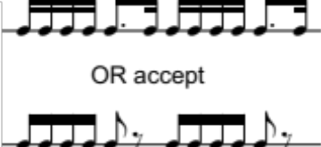  (or equivalent)
Question Three cont’d
Question | Achievement | Achievement with Merit | Achievement with Excellence
(a) (ix) |  | Identifies three main sections of the music using letter names:  - A B C | Precisely identifies three main sections of the music using letter names:  - A B A B C A B
(x) |  |  | Describes ONE way in which two sections contrast melodically, eg:  - A has more leaps than B  - the first half of A ascends, and the second half descends; B predominantly descends  - C has a new melody with notes of longer duration / that ends in the dominant key  - Compared to A, the melody in A' is heard in a different timbre / is played an octave higher / has an accompanying countermelody.  Other responses possible.
(b) (i) | Identifies the instrument that establishes the tonality:  - (acoustic) guitar. | Describes how the tonality is established:  - tonic and dominant notes (implying chords I and V) are played / repeated as a bass line.
(ii) | Identifies the time signature:  - Dd or ç | Gives ONE term that describes the metre, eg:  - common time  - (simple) quadruple
 | OR  - Bb or Ç or Bd | OR  - cut time  - alla breve  - (simple) duple.
(iii) | Identifies the instrument playing the melody:  - trumpet.
(iv) |  | Describes the change to the instrumentation when the theme is repeated:  - another trumpet is added.
(v) |  |  | Describes the harmonic relationship between the instruments at the end of the extract:  - the second trumpet plays below the first / in mostly (parallel) intervals / 6ths and 3rds.

Question Three cont’d
Question | Achievement | Achievement with Merit | Achievement with Excellence
(vi) | Identifies a rhythmic device used in the extract, eg:  - syncopation  - repetition. | Describes the rhythmic device, eg:  Device: syncopation  - accents are placed on beats that are normally weak. | Gives ONE piece of evidence to describe how the rhythmic device is used, eg:  Device: syncopation  - in the second bar of the melody, the down-beat to the following bar is anticipated / the note is played “ahead of the beat”.  Other responses possible.
(b) (vii) |  | Describes ONE way that the second theme contrasts with the opening theme, eg: | Describes TWO ways that the second theme contrasts with the opening theme, eg:
- the melody is different
- the key is different
- the instrumentation is different (the melody is played by a stringed / percussion instrument instead of the trumpet).
Other responses possible.

N1 | N2 | A3 | A4 | M5 | M6 | E7 | E8
ONE piece of evidence at Achievement level. | THREE pieces of evidence at Achievement level. | FIVE (of seventeen) pieces of evidence at any level. | SEVEN (of seventeen) pieces of evidence at any level. | FOUR (of fourteen) pieces of evidence at Merit or Excellence level. | SIX (of fourteen) pieces of evidence at Merit or Excellence level. | FOUR (of eight) pieces of evidence at Excellence level. | FIVE (of eight) pieces of evidence at Excellence level.
N0= No response; no relevant evidence.

Cut Scores
 | Not Achieved | Achievement | Achievement  with Merit | Achievement  with Excellence
Score range | 0 – 7 | 8 – 13 | 14 – 19 | 20 – 24

